No | Task | Status
1. | When I want to delete an activity, I get an error message  https://nazarethnet.com/admin/upload_marks/OS02My0yNzg=/839/1/ | I didn't find any errors when I deleted it. I've tried it several times and everything was successfully deleted. Maybe when you deleted it, there was a connection/browser lag which caused the error.
2. | On some occasions when we have duplicated activities from ROOM A to ROOM B, the activities  get out of order, this only happened to me in 2 situations. | DONE
3. | On this occasion, when duplicating the activities, they have been moved.  Transfer error  It should have been like this | DONE
4. | When making the transfer, student Sarai Machacca should no longer appear as an option  to transfer since she is deactivated in that course.  Also inactive from the entire platform so that it does not have access and continues to appear in  the transfer relationship.  But it appears here as active? | DONE
5. | The rating change history is not appearing. | DONE
6. | This error appears in the grade report, 1 activity is repeated  It should be like this: | Sorry, maybe you are mistaken, the one selected in the grades report is the class "Cosmetologia SALON 201" but what is shown is the class "Cosmetologia SALON 101"  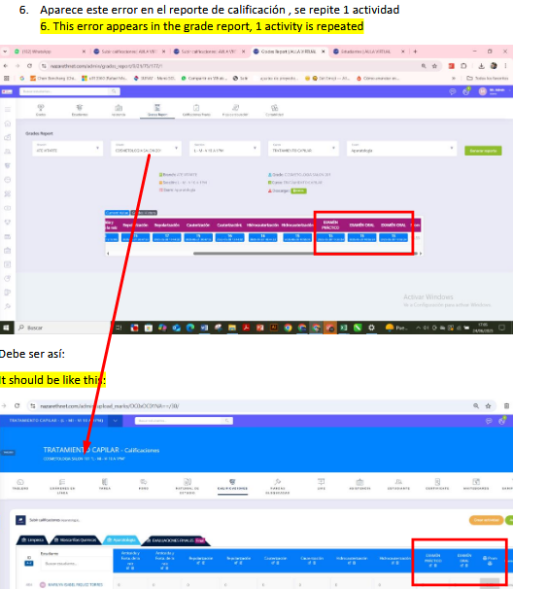
7. | In this part appear sections that have not been created, | DONE
8. | These pages don't work  Study material delete | DONE
9. | These pages don't work  Manage online exam question add multiple choice | DONE  This error happend because you not assign option, but i has fix it to prevent error.  Before you click ‘SAVE’ you need fill number of option with number ex:1,2,3,4 and click check icon and fill option and then you can save:  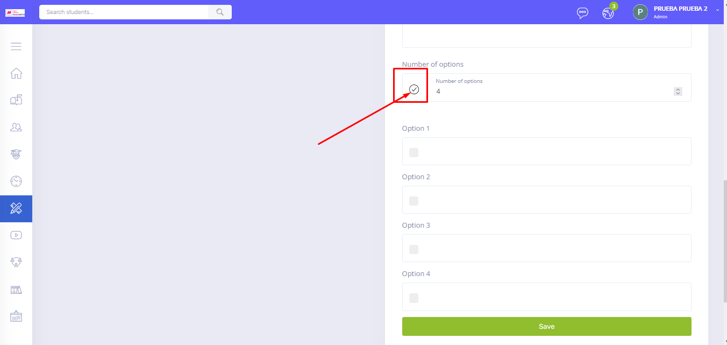
10. | When I make any changes to Section B and save, it returns to the Section A page. | DONE
11. | When I save a course modification, it redirects me to the home page of the locations. | DONE
12. | This filter is misconfigured, other courses from other sections appear to me. | DONE

